**# Hypothesis 1a - Org Advancement, broad succession periods**

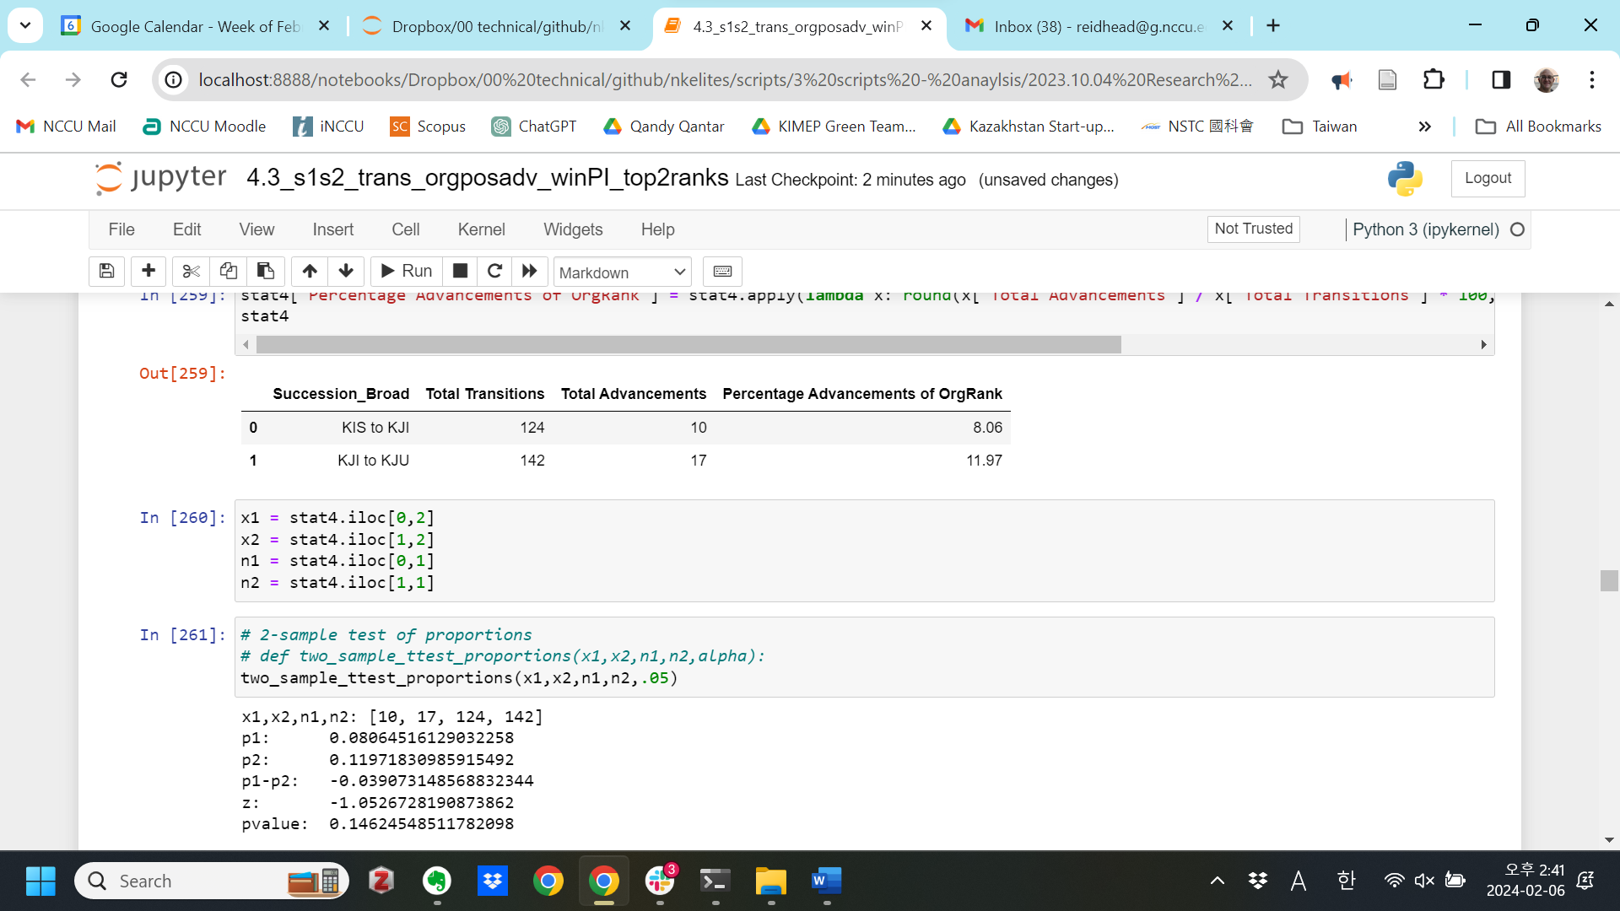

**# Hypothesis 1b - Position Advancement, broad succession periods**

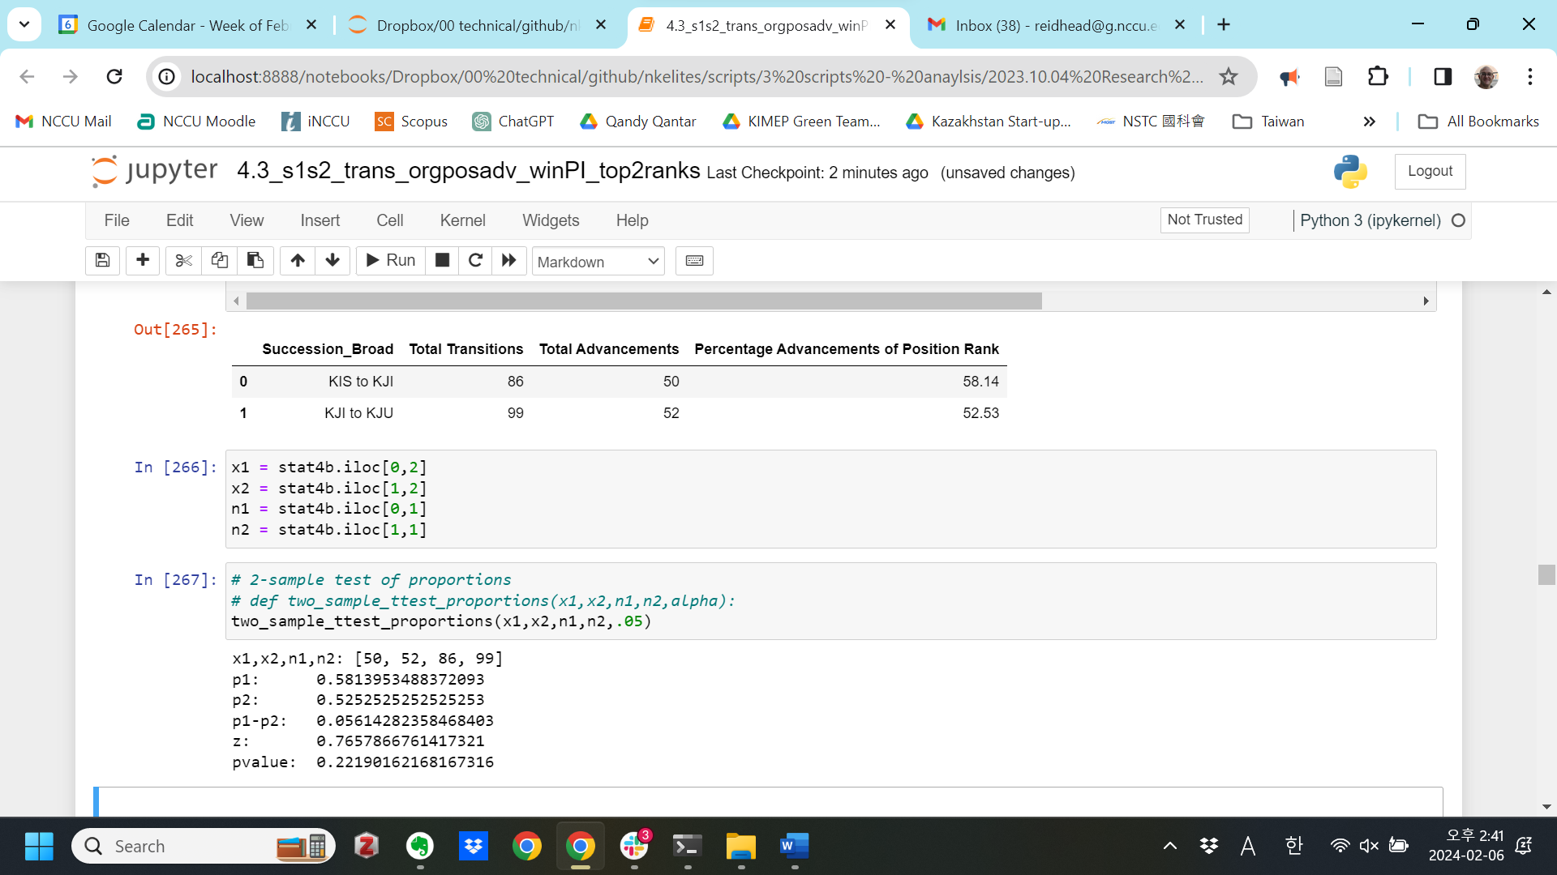

**# Hypothesis 1c - Org Advancement, broad succession, by Institution**

Government

Succession_Broad Total Transitions Total Advancements \

0 KIS to KJI 63 7

1 KJI to KJU 104 14

Percentage Advancements of OrgRank

0 11.11

1 13.46

x1,x2,n1,n2: [7, 14, 63, 104]

p1: 0.1111111111111111

p2: 0.1346153846153846

p1-p2: -0.023504273504273504

z: -0.44402348053502794

pvalue: 0.32851280389958204

Social

Succession_Broad Total Transitions Total Advancements \

0 KIS to KJI 24 3

1 KJI to KJU 16 1

Percentage Advancements of OrgRank

0 12.50

1 6.25

x1,x2,n1,n2: [3, 1, 24, 16]

p1: 0.125

p2: 0.0625

p1-p2: 0.0625

z: 0.6454972243679028

pvalue: 0.25930250821436274

Party

Succession_Broad Total Transitions Total Advancements \

0 KIS to KJI 28 0

1 KJI to KJU 0 0

Percentage Advancements of OrgRank

0 0.0

1 NaN

x1,x2,n1,n2: [0, 0, 28, 0]

p1: 0.0

p2: nan

p1-p2: nan

z: nan

pvalue: nan

Military

Succession_Broad Total Transitions Total Advancements \

0 KIS to KJI 9 0

1 KJI to KJU 22 2

Percentage Advancements of OrgRank

0 0.00

1 9.09

x1,x2,n1,n2: [0, 2, 9, 22]

p1: 0.0

p2: 0.09090909090909091

p1-p2: -0.09090909090909091

z: -0.9352048708546269

pvalue: 0.17484136440031395

**# Hypothesis 1d - Position Advancement, broad succession, by Institution**

Government

Succession_Broad Total Transitions Total Advancements \

0 KIS to KJI 39 27

1 KJI to KJU 76 30

Percentage Advancements

0 69.23

1 39.47

x1,x2,n1,n2: [27, 30, 39, 76]

p1: 0.6923076923076923

p2: 0.39473684210526316

p1-p2: 0.2975708502024291

z: 3.0215304900211017

pvalue: 0.0012575015501833375**

Social

Succession_Broad Total Transitions Total Advancements \

0 KIS to KJI 15 13

1 KJI to KJU 9 8

Percentage Advancements

0 86.67

1 88.89

x1,x2,n1,n2: [13, 8, 15, 9]

p1: 0.8666666666666667

p2: 0.8888888888888888

p1-p2: -0.022222222222222143

z: -0.1593638145779186

pvalue: 0.43669112315483205

Party

Succession_Broad Total Transitions Total Advancements \

0 KIS to KJI 25 3

1 KJI to KJU 0 0

Percentage Advancements

0 12.0

1 NaN

x1,x2,n1,n2: [3, 0, 25, 0]

p1: 0.12

p2: nan

p1-p2: nan

z: nan

pvalue: nan

Military

Succession_Broad Total Transitions Total Advancements \

0 KIS to KJI 7 7

1 KJI to KJU 14 14

Percentage Advancements

0 100.0

1 100.0

x1,x2,n1,n2: [7, 14, 7, 14]

p1: 1.0

p2: 1.0

p1-p2: 0.0

z: nan

pvalue: nan

**# Hypothesis 2a - Org Advancement, narrow succession periods**

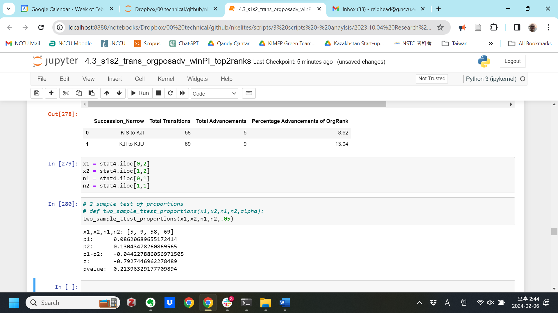

**# Hypothesis 2b - Position Advancement, narrow succession periods**

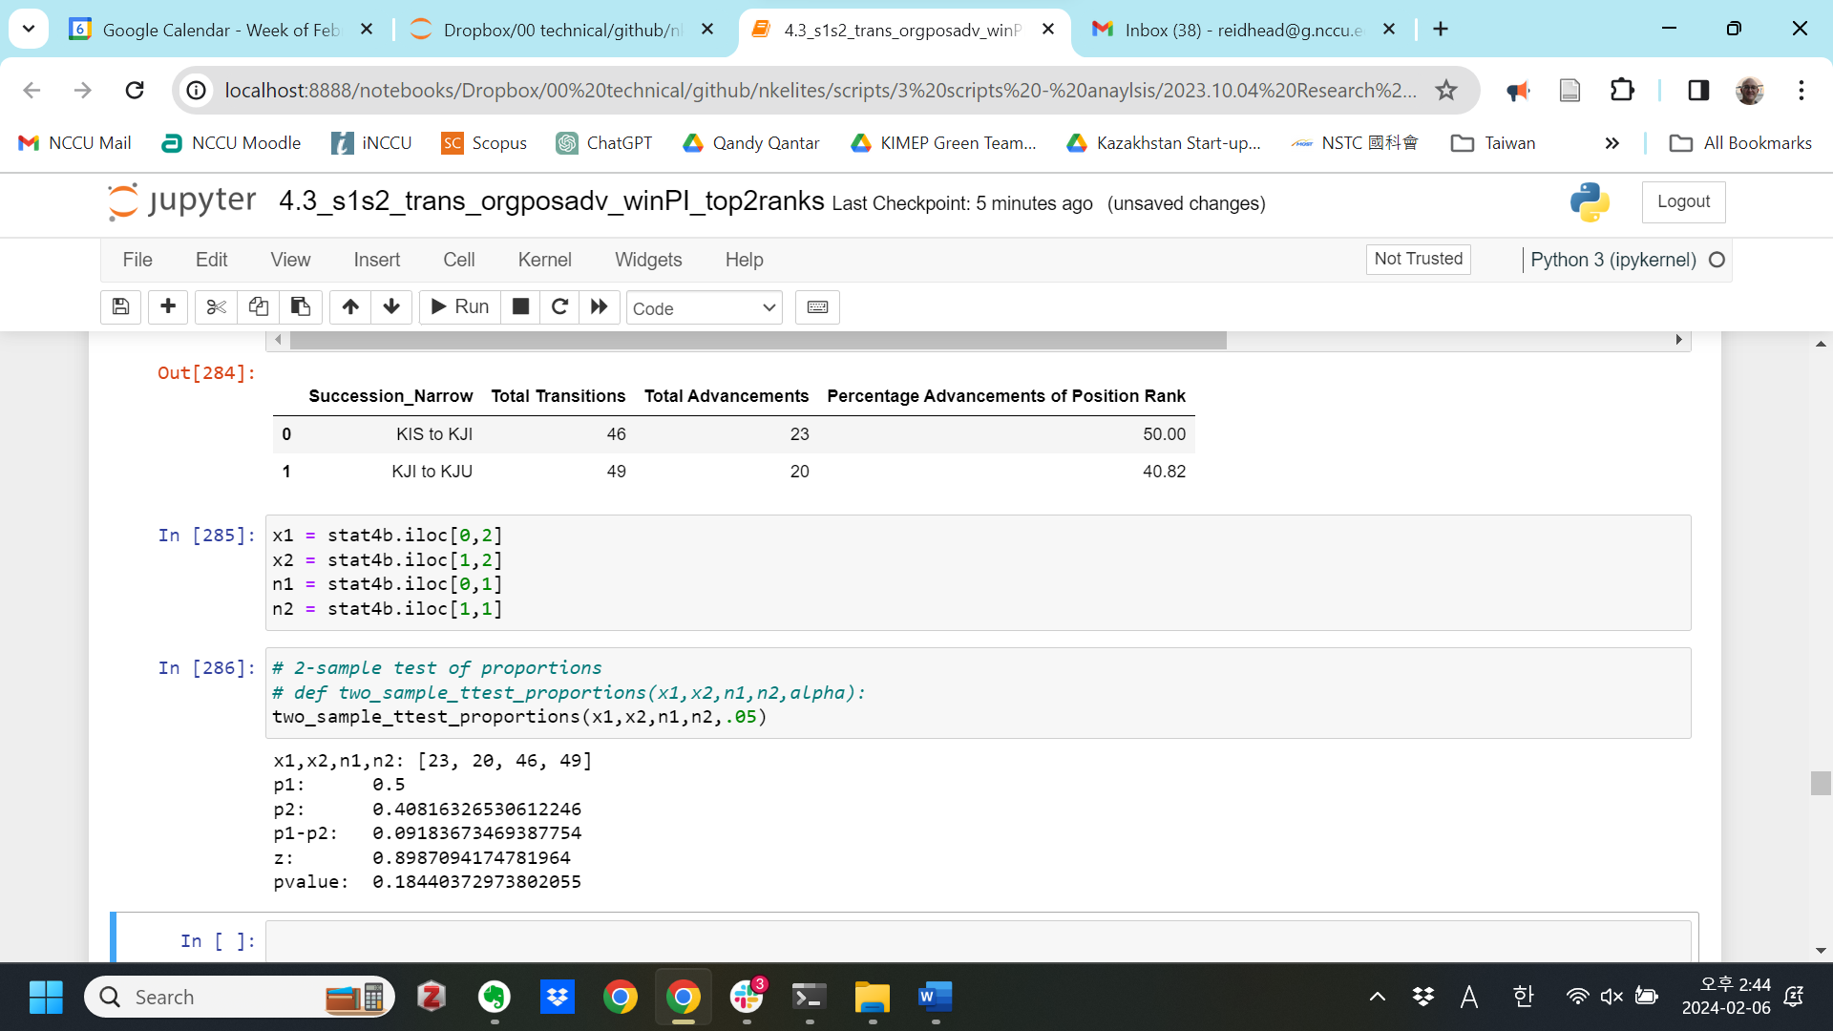

**# Hypothesis 2c - Org Advancement, narrow succession, by Institution**

Government

Succession_Narrow Total Transitions Total Advancements \

0 KIS to KJI 33 3

1 KJI to KJU 56 8

Percentage Advancements of OrgRank

0 9.09

1 14.29

x1,x2,n1,n2: [3, 8, 33, 56]

p1: 0.09090909090909091

p2: 0.14285714285714285

p1-p2: -0.05194805194805194

z: -0.7192363178658627

pvalue: 0.2359976629109708

Social

Succession_Narrow Total Transitions Total Advancements \

0 KIS to KJI 6 1

1 KJI to KJU 1 False

Percentage Advancements of OrgRank

0 16.67

1 0.00

x1,x2,n1,n2: [1, False, 6, 1]

p1: 0.16666666666666666

p2: 0.0

p1-p2: 0.16666666666666666

z: 0.44095855184409843

pvalue: 0.32962150184631533

Party

Succession_Narrow Total Transitions Total Advancements \

0 KIS to KJI 13 0

1 KJI to KJU 0 0

Percentage Advancements of OrgRank

0 0.0

1 NaN

x1,x2,n1,n2: [0, 0, 13, 0]

p1: 0.0

p2: nan

p1-p2: nan

z: nan

pvalue: nan

Military

Succession_Narrow Total Transitions Total Advancements \

0 KIS to KJI 6 1

1 KJI to KJU 12 1

Percentage Advancements of OrgRank

0 16.67

1 8.33

x1,x2,n1,n2: [1, 1, 6, 12]

p1: 0.16666666666666666

p2: 0.08333333333333333

p1-p2: 0.08333333333333333

z: 0.5303300858899106

pvalue: 0.29794154528258887

**# Hypothesis 2d - Position Advancement, narrow succession, by Institution**

Government

Succession_Narrow Total Transitions Total Advancements \

0 KIS to KJI 25 16

1 KJI to KJU 42 13

Percentage Advancements

0 64.00

1 30.95

x1,x2,n1,n2: [16, 13, 25, 42]

p1: 0.64

p2: 0.30952380952380953

p1-p2: 0.3304761904761905

z: 2.640471166016987

pvalue: 0.0041395418644954995**

Social

Succession_Narrow Total Transitions Total Advancements \

0 KIS to KJI 5 3

1 KJI to KJU 0 0

Percentage Advancements

0 60.0

1 NaN

x1,x2,n1,n2: [3, 0, 5, 0]

p1: 0.6

p2: nan

p1-p2: nan

z: nan

pvalue: nan

Party

Succession_Narrow Total Transitions Total Advancements \

0 KIS to KJI 12 0

1 KJI to KJU 0 0

Percentage Advancements

0 0.0

1 NaN

x1,x2,n1,n2: [0, 0, 12, 0]

p1: 0.0

p2: nan

p1-p2: nan

z: nan

pvalue: nan

Military

Succession_Narrow Total Transitions Total Advancements \

0 KIS to KJI 4 4

1 KJI to KJU 7 7

Percentage Advancements

0 100.0

1 100.0

x1,x2,n1,n2: [4, 7, 4, 7]

p1: 1.0

p2: 1.0

p1-p2: 0.0

z: nan

pvalue: nan